**Climate change aggravates bog species extinctions in the Black Forest (Germany)**

**Supporting Information**

**Table S1**: Sites included in the study (n=124).

|  |  |  |  |  |  |  |  |  |  |  |  |  |  |  |  |  |  |
| --- | --- | --- | --- | --- | --- | --- | --- | --- | --- | --- | --- | --- | --- | --- | --- | --- | --- |
| No. | Site ID | Site name | Natura 2000 site ID | Altitude [m] | Area [ha] | Survey 1972-1980 (n=115) | Survey 1981-1992 (n=62) | Survey 1993-1998 (n=101) | Survey 1999-2016 (n=86) | Survey 2017   (n=20) | Survey 2018  (n=98) | Survey 2019  (n=39) | Survey 2020  (n=99) | Number of declining species (out of 37) | Number of extinct species at this site | Mean change in occupancy of declining species (out of 37) | Land use |
| 1 | 159 | Zastler Kar | 8114-311 | 1340 | 21.9 | x | x | x | x |  | x | x | x | 20 | 4 | -0.2 | - |
| 2 | 160 | Quellgebiet Sägenbach | 8114-311 | 1450 | 0.4 | x |  |  |  |  | x | x | x | 15 | 1 | -0.067 | g |
| 3 | 161 | Quellmoor Waldhäusle | 8114-341 | 1150 | 2.3 | x | x | x | x | x | x | x | x | 15 | 1 | -0.067 | g |
| 4 | 162 | Eschengrundmoos | 8114-341 | 1000 | 10.7 | x | x |  | x |  | x |  | x | 21 | 5 | -0.238 | (f) |
| 5 | 163 | Kesslermoos | 8114-341 | 950 | 10 | x | x |  | x |  | x |  | x | 16 | 1 | -0.062 | (f) |
| 6 | 164 | Filz am Bankenhansenhof | - | 950 | 3.4 | x | x |  | x | x |  |  | x | 7 | 2 | -0.286 | f |
| 7 | 165 | Seewald | 8114-341 | 850 | 14.3 | x | x | x | x |  | x |  | x | 11 | 4 | -0.364 | m,f |
| 8 | 166 | Feldberg-Grüble | 8114-311 | 1300 | 21 | x | x | x | x |  | x | x | x | 21 | 3 | -0.143 | g |
| 9 | 167 | Feldseemoor | 8114-311 | 1100 | 1.9 | x | x |  | x |  | x |  | x | 22 | 4 | -0.182 | - |
| 10 | 168 | Waldhofmoor | 8114-311 | 1000 | 3.1 | x | x | x | x |  | x | x | x | 17 | 4 | -0.235 | - |
| 11 | 169 | Kunzenmoos | 8114-341 | 920 | 3.6 | x | x | x | x |  | x | x |  | 3 | 0 | 0 | - |
| 12 | 170 | Behabühl | - | 985 | 4.4 | x | x | x | x | x |  |  |  | 6 | 4 | -0.667 | f |
| 13 | 171 | Vorder-Bärental | - | 950 | 1.9 | x |  |  |  |  |  | x |  | 2 | 2 | -1 | f |
| 14 | 172 | Unteres Rotmeer | 8114-341 | 965 | 7.4 | x |  | x | x |  | x | x | x | 12 | 1 | -0.083 | - |
| 15 | 173 | Oberes Rotmeer | 8114-341 | 990 | 19 | x |  |  | x |  | x |  | x | 8 | 2 | -0.25 | (f) |
| 16 | 174 | Reut (Feldberghalle) |  | 960 | 4.2 | x |  |  | x |  | x |  | x | 6 | 1 | -0.167 | (f) |
| 17 | 175 | Grafenmatt/ Kriegsbachquelle | 8114-311 | 1345 | 8.8 | x | x | x |  |  | x |  | x | 17 | 0 | 0 | g |
| 18 | 176 | Heitermoos | 8114-311 | 1150 | 20.4 | x | x |  | x |  | x | x | x | 13 | 1 | -0.077 | (f) |
| 19 | 177 | Kriegshalde | 8114-311 | 1200 | 50.3 | x |  |  | x |  | x |  |  | 6 | 4 | -0.667 | - |
| 20 | 178 | Hirschbäder | 8114-311 | 1280 | 8 | x | x |  | x |  | x |  | x | 12 | 1 | -0.083 | - |
| 21 | 179 | Windgfällweiher | 8114-341 | 970 | 3.4 | x | x | x | x |  | x | x | x | 13 | 2 | -0.154 | - |
| 22 | 180 | Kähnermoos | - | 985 | 6.6 | x |  | x | x |  |  | x |  | 7 | 3 | -0.429 | (f) |
| 23 | 181 | Untere Sedell | 8114-311 | 1280 | 13.9 | x | x | x | x |  | x |  | x | 15 | 3 | -0.2 | - |
| 24 | 182 | Krunkelbach-Quellgebiet | 8114-311 | 1200 | 6.1 | x |  | x |  |  | x | x | x | 11 | 1 | -0.091 | g |
| 25 | 183 | Scheibenlechtenmoos | 8114-311 | 1100 | 2.2 | x | x |  | x |  | x | x | x | 14 | 3 | -0.214 | - |
| 26 | 184 | Talschluss Oberaha | - | 985 | 13.4 | x | x |  | x | x |  |  | x | 6 | 1 | -0.167 | g,f |
| 27 | 185 | Scheuermatt | - | 965 | 5.9 | x | x |  | x | x |  |  | x | 5 | 0 | 0 | (f) |
| 28 | 186 | Schluchsee-Weiher Lunzihof | - | 940 | 5 | x |  | x |  | x |  |  | x | 6 | 1 | -0.167 | - |
| 29 | 187 | Parkplatz am Lunzihof | - | 945 | 2.3 | x |  | x |  | x |  |  | x | 4 | 4 | -1 | g |
| 30 | 188 | Hangmoor unterh. Kirchweg | - | 950 | 5.1 | x | x |  | x | x |  |  | x | 8 | 3 | -0.375 | g,f |
| 31 | 189 | Stellemoos am Eck | 8114-311 | 1135 | 2 | x | x | x | x |  | x | x | x | 6 | 0 | 0 | - |
| 32 | 190 | Eschenmoos | - | 1130 | 22.5 | x | x |  | x | x |  | x | x | 14 | 4 | -0.286 | (f) |
| 33 | 191 | Wüstengraben | - | 990 | 5.2 | x | x |  |  | x |  |  | x | 12 | 1 | -0.083 | - |
| 34 | 192 | Urseemoor | 8114-341 | 835 | 9.6 | x | x | x | x |  | x | x | x | 18 | 2 | -0.111 | - |
| 35 | 193 | Sommerberg n. Lenzkirch | - | 920 | 33 | x |  |  | x |  |  | x |  | 3 | 2 | -0.667 | f |
| 36 | 194 | Große Matte | - | 910 | 9.3 | x | x | x |  | x |  | x |  | 3 | 1 | -0.333 | g |
| 37 | 195 | Wolfsmoos | - | 850 | 4.1 | x |  | x | x | x |  | x | x | 7 | 0 | 0 | (m) |
| 38 | 196 | Zopfelsäge | - | 770 | 4.3 | x | x | x |  | x |  | x |  | 3 | 1 | -0.333 | m |
| 39 | 198 | Glaserhaus | - | 1060 | 9.4 | x |  | x |  | x |  | x |  | 9 | 4 | -0.444 | - |
| 40 | 199 | Dresselbach-Winterberg | - | 1010 | 6.2 | x | x |  | x | x |  | x |  | 7 | 1 | -0.143 | (g),(f) |
| 41 | 200 | Hinterhalden | 8315-341 | 1000 | 19 | x | x | x | x |  | x | x |  | 13 | 7 | -0.538 | (f) |
| 42 | 201 | Östliche Aubachquelle | - | 1000 | 9.4 | x | x | x |  | x |  |  | x | 16 | 6 | -0.375 | g |
| 43 | 202 | Blummoos | - | 1000 | 38.9 | x |  |  |  |  |  | x |  | 1 | 0 | 0 | f |
| 44 | 216 | Taubenmoos | 8114-311 | 1000 | 24.5 | x |  | x | x |  | x |  | x | 14 | 1 | -0.071 | g(,f) |
| 45 | 217 | Moos östl. Weierle | 8114-311 | 850 | 19.7 | x |  | x | x | x |  | x |  | 8 | 3 | -0.375 | f |
| 46 | 218 | Westliches Habsmoos | 8214-341 | 1050 | 5.9 | x | x | x | x | x |  |  | x | 13 | 4 | -0.308 | (g) |
| 47 | 219 | Östliches Habsmoos | 8214-341 | 985 | 9.7 | x | x | x | x | x |  |  | x | 15 | 2 | -0.133 | g,(f) |
| 48 | 220 | Neumatt | 8214-343 | 1010 | 20.7 | x | x | x | x |  | x |  | x | 20 | 3 | -0.15 | (g) |
| 49 | 221 | Lampenschweine | 8214-343 | 1060 | 4.4 | x | x | x |  |  | x |  | x | 15 | 5 | -0.333 | (g),(f) |
| 50 | 222 | Filz östl. Mutterslehen | 8214-343 | 930 | 7.8 | x |  | x | x |  | x | x | x | 9 | 3 | -0.333 | (f) |
| 51 | 224 | Blutmoos | 8214-343 | 1040 | 3.9 | x |  | x |  |  | x |  | x | 12 | 4 | -0.333 | - |
| 52 | 225 | Kohlhüttenmoos | 8214-343 | 1020 | 6.6 | x | x | x | x |  | x |  | x | 20 | 4 | -0.2 | (g),(f) |
| 53 | 226 | Brendenkopfkar | 8214-343 | 1070 | 1.2 | x | x | x | x |  | x |  | x | 7 | 5 | -0.714 | (f) |
| 54 | 227 | Ramsenbächle Nord | 8214-343 | 1040 | 1.2 | x | x | x |  |  | x |  | x | 14 | 6 | -0.429 | g |
| 55 | 228 | Schorrmättle | 8214-343 | 1030 | 3.2 | x | x | x | x |  | x |  |  | 13 | 9 | -0.692 | m,f |
| 56 | 229 | Neuwies | 8214-343 | 1000 | 14.8 | x |  | x | x |  | x |  | x | 17 | 2 | -0.118 | (f) |
| 57 | 230 | Horbacher Moor | 8214-343 | 990 | 3.9 | x |  | x | x |  | x |  | x | 18 | 5 | -0.278 | - |
| 58 | 231 | Horbacher Klosterweiher | 8214-343 | 950 | 2 | x |  | x |  |  | x |  | x | 3 | 0 | 0 | - |
| 59 | 232 | Laite | 8214-343 | 900 | 1.4 | x |  | x |  |  | x |  | x | 13 | 4 | -0.308 | g |
| 60 | 233 | Rüttewies | 8214-343 | 990 | 3.6 | x | x | x |  |  | x |  | x | 15 | 2 | -0.133 | m |
| 61 | 234 | Schwandwaldmoor | 8214-343 | 960 | 6.5 | x |  | x | x |  | x |  | x | 15 | 7 | -0.467 | (f) |
| 62 | 235 | Althüttenmoos | 8214-343 | 1020 | 18.9 | x | x | x | x |  | x |  | x | 16 | 1 | -0.062 | (f) |
| 63 | 236 | Niedermoor s. Whs Lindau | 8214-343 | 910 | 0.7 | x | x | x | x |  |  | x | x | 11 | 5 | -0.455 | f |
| 64 | 237 | Langmoos sw. Lindau | 8214-343 | 960 | 4.5 | x |  | x | x |  |  | x | x | 4 | 0 | 0 | (f) |
| 65 | 238 | Moor südl. Lindau | 8214-343 | 940 | 9.7 | x | x | x | x |  | x |  | x | 19 | 6 | -0.316 | (f) |
| 66 | 239 | Fohrenmoos sw. Ibach | 8214-343 | 985 | 9.1 | x |  | x | x |  | x |  | x | 9 | 4 | -0.444 | - |
| 67 | 240 | Ibacher Moos/ Klusenmoos | 8214-343 | 910 | 27.1 | x | x | x | x |  | x |  | x | 19 | 5 | -0.263 | (f) |
| 68 | 241 | Käswies | 8214-343 | 990 | 3.9 | x |  | x |  |  | x |  | x | 14 | 2 | -0.143 | m |
| 69 | 242 | Wolfersmatt | 8214-343 | 950 | 4.3 | x |  | x |  |  | x |  |  | 14 | 11 | -0.786 | (f),(m) |
| 70 | 243 | Im Hölzle, Oberbildstein | 8214-343 | 820 | 0.8 | x |  | x |  |  | x |  |  | 6 | 6 | -1 | - |
| 71 | 244 | Oberbildstein | 8214-343 | 730 | 2.1 | x |  | x |  |  | x |  |  | 2 | 2 | -1 | g |
| 72 | 245 | Brunnmättlemoos | 8214-343 | 950 | 18 | x | x | x | x |  | x | x | x | 13 | 2 | -0.154 | (f) |
| 73 | 246 | unteres Silberbrunnenmoos | 8214-343 | 900 | 13.8 | x | x | x | x |  | x |  | x | 21 | 5 | -0.238 | - |
| 74 | 247 | Fohrenmoos | 8214-343 | 980 | 18.9 | x | x | x | x |  | x |  | x | 22 | 6 | -0.273 | - |
| 75 | 248 | Schwarze Säge | 8214-343 | 880 | 7.4 | x | x | x | x |  | x |  | x | 13 | 1 | -0.077 | m |
| 76 | 249 | oberes Silberbrunnenmoos | 8214-343 | 930 | 7.1 | x | x | x | x |  | x |  | x | 18 | 3 | -0.167 | - |
| 77 | 250 | Hirnimoos | 8214-343 | 960 | 3.1 | x | x | x | x |  | x |  | x | 16 | 3 | -0.188 | - |
| 78 | 251 | Obere Furt Ibach | - | 780 | 2.4 | x |  |  |  |  | x |  |  | 9 | 5 | -0.556 | - |
| 79 | 252 | Hangmoor ö. Schw. Säge | - | 900 | 2.8 | x | x | x | x |  | x |  | x | 8 | 2 | -0.25 | (f) |
| 80 | 253 | Strickbach-Unterlauf | 8214-343 | 900 | 3.4 | x |  | x | x |  | x |  | x | 18 | 7 | -0.389 | - |
| 81 | 254 | Fröhnd | - | 910 | 4.4 | x |  | x |  |  | x | x |  | 5 | 1 | -0.2 | m,g |
| 82 | 255 | Strickmattmoos | 8214-343 | 925 | 4.2 | x |  | x | x |  | x |  | x | 16 | 9 | -0.562 | - |
| 83 | 256 | Leimenlöcher/ Spielmanns. | 8214-343 | 940 | 28.6 | x | x | x | x |  | x |  | x | 23 | 4 | -0.174 | - |
| 84 | 257 | Bruggmatt | 8214-343 | 940 | 0.8 | x | x | x | x |  | x |  | x | 19 | 3 | -0.158 | m |
| 85 | 258 | Im Luchle | 8214-343 | 900 | 3.7 | x |  | x | x |  | x |  | x | 15 | 6 | -0.4 | - |
| 86 | 259 | Bei den vier Wegen | 8214-343 | 975 | 0.5 | x |  |  |  |  | x |  |  | 6 | 1 | -0.167 | - |
| 87 | 260 | Rüttebach-Quelle, Hofmatt | 8214-343 | 900 | 10.8 | x | x | x | x |  | x |  | x | 18 | 9 | -0.5 | (f) |
| 88 | 261 | Vogelbach-Oberlauf | 8214-343 | 870 | 5.4 | x | x | x | x |  | x |  | x | 17 | 10 | -0.588 | - |
| 89 | 262 | Ennersbacher Moor | 8214-343 | 930 | 13.9 | x | x | x | x |  | x |  | x | 23 | 8 | -0.348 | - |
| 90 | 263 | Tannholz | - | 850 | 5.3 | x |  | x | x |  | x |  |  | 17 | 11 | -0.647 | f |
| 91 | 264 | Berg n. Wolpadingen | - | 950 | 1.9 | x |  | x | x |  | x |  |  | 4 | 4 | -1 | f |
| 92 | 265 | Tiefenhäuserner Moor | 8314-341 | 920 | 3.6 | x |  | x | x |  | x |  | x | 13 | 1 | -0.077 | - |
| 93 | 286 | Lochhäuser | 8413-341 | 940 | 4 | x |  | x | x |  | x | x |  | 9 | 7 | -0.778 | (m),(g) |
| 94 | 287 | Schüsseln | 8413-341 | 885 | 5.2 | x |  | x | x |  | x | x | x | 8 | 3 | -0.375 | (m) |
| 95 | 288 | Giersbacher | 8413-341 | 850 | 14.5 | x | x | x | x |  | x | x | x | 13 | 2 | -0.154 | m |
| 96 | 289 | Tanzwasen bei Segeten | 8413-341 | 900 | 6.4 | x |  | x | x |  | x |  | x | 10 | 2 | -0.2 | - |
| 97 | 290 | Torfstich bei Segeten | 8413-341 | 870 | 5 | x |  | x |  |  | x | x |  | 6 | 3 | -0.5 | (g) |
| 98 | 291 | Moos nordw. Hogschür | 8413-341 | 800 | 7.7 | x |  | x | x |  | x | x | x | 9 | 3 | -0.333 | m |
| 99 | 292 | Torfstich Hogschür | 8413-341 | 790 | 4.2 | x |  | x | x |  | x | x | x | 12 | 2 | -0.167 | (m) |
| 100 | 293 | Platzmoos / Tannenmatt | 8413-341 | 780 | 15.1 | x | x | x | x |  | x |  | x | 18 | 8 | -0.444 | (g),(m) |
| 101 | 294 | Niedermoor Hottingen | 8413-341 | 700 | 3.8 | x |  | x | x |  | x |  | x | 14 | 7 | -0.5 | m |
| 102 | 295 | Weihermoosmatte | 8413-341 | 665 | 14.1 | x | x | x | x |  | x |  | x | 19 | 8 | -0.421 | (m) |
| 103 | 296 | Hierholzer Weiher | 8214-343 | 905 | 2.4 | x |  | x |  |  | x |  | x | 1 | 0 | 0 | (g) |
| 104 | 297 | Aue südl. Vogelbach | - | 760 | 3.2 | x |  | x |  |  | x |  | x | 2 | 0 | 0 | g |
| 105 | 298 | Eschenbächle nw Görwihl | - | 715 | 1.6 | x |  | x |  |  | x |  | x | 3 | 3 | -1 | - |
| 106 | 383 | Rinkenwiesen | 8114-311 | 1180 | 5.8 | x | x |  |  |  | x |  | x | 11 | 1 | -0.091 | g |
| 107 | 400 | Taubenmoos-Ost | 8114-311 | 990 | 14.2 | x |  | x | x |  | x |  | x | 14 | 5 | -0.357 | - |
| 108 | 401 | Taubenmoos-West | 8114-311 | 1050 | 3.6 | x |  | x |  |  | x |  | x | 10 | 3 | -0.3 | g |
| 109 | 407 | Hoheck bei Horbach | - | 1010 | 1.4 | x |  | x |  |  | x | x | x | 2 | 0 | 0 | m |
| 110 | 408 | Schwarzenbächle n. Lindau | 8214-343 | 980 | 11.9 | x | x | x | x |  | x |  | x | 19 | 3 | -0.158 | g |
| 111 | 409 | Lindauer Moos | 8214-343 | 940 | 14.6 | x |  | x |  |  | x |  | x | 18 | 2 | -0.111 | g |
| 112 | 410 | Dukatenmoos | 8214-343 | 960 | 3.4 | x |  | x | x |  | x |  | x | 16 | 4 | -0.25 | - |
| 113 | 411 | Geißhaltermoos | 8214-343 | 940 | 13 | x | x | x | x |  | x |  | x | 15 | 6 | -0.4 | - |
| 114 | 412 | Schwammmatt s. Ibach | 8214-343 | 920 | 5.5 | x |  | x | x |  | x |  | x | 14 | 4 | -0.286 | (m) |
| 115 | 601 | Mittleres Habsmoos | 8214-341 | 1000 | 10.8 |  |  | x |  | x |  |  | x | 13 | 1 | -0.077 | (g) |
| 116 | 602 | Ibach-Quellmor | 8214-343 | 1060 | 4.1 |  |  | x |  |  | x |  | x | 15 | 0 | 0 | g |
| 117 | 609 | Kaibenmoos | 8413-341 | 870 | 5.4 |  |  | x | x |  |  | x | x | 6 | 2 | -0.333 | (m) |
| 118 | 611 | Turbenmoos | 8214-343 | 945 | 10.3 | x | x | x |  |  | x |  | x | 10 | 2 | -0.2 | - |
| 119 | 612 | Sonnmättlemoos | 8214-343 | 940 | 0.7 |  |  | x | x |  | x |  |  | 7 | 1 | -0.143 | - |
| 120 | 613 | Marksteinmoos | 8214-343 | 970 | 2.6 |  | x | x | x |  | x |  | x | 10 | 2 | -0.2 | - |
| 121 | 614 | Auf den Köpfen | 8214-343 | 1050 | 1.5 |  |  | x | x |  | x |  | x | 13 | 2 | -0.154 | - |
| 122 | 615 | Ramsenloch | 8214-343 | 950 | 2.2 |  |  | x | x |  | x |  | x | 9 | 0 | 0 | g |
| 123 | 616 | Lehenweide | 8214-343 | 930 | 5.9 |  |  | x |  |  | x | x | x | 10 | 0 | 0 | (g) |
| 124 | 626 | Höll | - | 840 | 1.2 |  |  | x |  |  | x |  | x | 4 | 0 | 0 | g |

Site ID: number used in the map in Figure 1; Natura 2000 Site ID: official number of the Natura 2000 habitat site, several sites may belong to one Natura 2000 site or a site may not belong to any Natura 2000 site (“-“); The sources of the four different survey periods are listed in Appendix Table S2. For the most recent systematic survey the exact survey year is shown; Number of declining species (out of 51): number of the species that declined (see Appendix Table S3) found at this site; Number of declining species extinct at this site: number of the species that declined (see Appendix Table S3) that went extinct at this site; Mean change in occupancy of declining species (out of 51): Mean change in occupancy of the species that declined (see Appendix Table S3) that occurred at this site; Land use. f: forestry, m: mowing, g: grazing. Land use is shown in brackets when it applies to only parts of the bog complex.

**Table S2**: Sources of the survey data

|  |  |  |  |  |
| --- | --- | --- | --- | --- |
| Source | Number of species lists | Investigation period | Publication year | Reference |
| Dierßen, B. & Dierßen, K. | 114 1 | 1972-1980 | 1984 | Vegetation und Flora der Schwarzwaldmoore. *Veröffentlichungen für Naturschutz und Landschaftspflege in Baden-Württemberg. Beihefte.* 39, 1-512. Karlsruhe, Germany. |
| Flintrop, Thomas | 27 | 1985-2000 | unpublished | Vegetation plots |
| Sperle, Thomas | 119 | 2017-2020 | unpublished | Systematic species inventories |
| Görger, A. | 19 | 1985-2019 | unpublished | Commented species lists |
| Köppler, Dietlinde | 59 | 1987-2019 | unpublished | Commented species lists |
| Nowak, B. & Schulz, B. | 6 | 1992-2000 | 2002 | Wiesen, Naturschutz-Spectrum Themen 93, 368 S.;Verlag Regionalkultur, Heidelberg. |
| Schuhwerk, F. | 6 2 | 1975-1980 | 1988 | Naturnahe Vegetation im Hotzenwald (Südöstlicher Schwarzwald). Dissertation Univ. Regensburg, 1-526 S. Regensburg, Germany |
| Seifert, C. | 8 | 1995-2019 | unpublished | Commented species lists |
| Wein, G. & Brändle, M. | 1 | 1991 | unpublished | Bedrohte Wiesen- und Moorstandorte auf dem Gebiet der Gemeinde Görwihl (Landkreis Waldshut/ Südschwarzwald), 116 S.. |
| Erfassung der Lebensraumtypen der Managementpläne der Natura2000 Gebiete in Baden-Württemberg | 7 | 2018 | Online database | <https://udo.lubw.baden-wuerttemberg.de/public/pages/home/welcome.xhtml> |
| Offenland-Biotopkartierung des Landes Baden-Württemberg | 132 | 1981-2018 | Online database | <https://udo.lubw.baden-wuerttemberg.de/public/pages/home/welcome.xhtml> |
| Wald-Biotopkartierung des Landes Baden-Württemberg | 227 | 1980-2017 | Online database | <https://udo.lubw.baden-wuerttemberg.de/public/pages/home/welcome.xhtml> |

1 Out of these 114 lists, 106 had been compiled by Dierßen & Dierßen themselves, while further 7 lists were surveys made by Schuhwerk (unpublished at that time) and 1 compiled in Dierßen & Dierßen (1984) from literature.

2 Out of these 6 lists, 5 had been already partially included in the data compiled by Dierßen & Dierßen. These lists were complemented and 1 further list was added.

**Table S3:** Species surveyed in the study (n=88).

|  |  |  |  |  |  |  |  |  |
| --- | --- | --- | --- | --- | --- | --- | --- | --- |
| Species | Family | Frequency | Mean relative change | Significance | Surveyed by Dierßen | Dispersal mode | Habitat preference | Geographic distribution range |
| Agrostis canina | Poaceae | 113 | 0.460 | <0.001 |  | s,v | M | sm/mo-b·c1-6EUR-WSIB |
| Alnus glutinosa | Betulaceae | 34 | 0.147 | 0.332 |  | s,(v) | W | m/mo-b·c1-5EUR-(WSIB) |
| Andromeda polifolia | Ericaceae | 51 | -0.157 | 0.057 | D | (s),v | B | sm/mo-b·c2-6CIRCPOL |
| Angelica sylvestris | Apiaceae | 81 | 0.272 | <0.001 |  | s | F | m/mo-b·c1-6EUR-WAS |
| Bartsia alpina | Scrophulariaceae | 9 | *-0.333* | *0.250* | D | s,v | R | sm/alp-arct·c1-5EUR-OAM |
| Bellidiastrum michelii | Asteraceae | 2 | *-0.500* | *1.000* |  | s,v | R | sm/salp-stemp/dealp·c2-4EUR |
| Betula nana | Betulaceae | 1 | 0.000 | 1.000 |  | (s),v | B | temp/mo-arct·c3-7EUR-WSIB |
| Betula pubescens | Betulaceae | 75 | 0.333 | <0.001 |  | s | W | sm-b·c1-6EUR-SIB |
| Bistorta officinalis | Polygonaceae | 97 | 0.309 | <0.001 |  | s,v | F | sm/mo-arct·c2-8EURAS-WAM |
| Calamagrostis phragmitoides | Poaceae | 3 | 0.000 | 1.000 |  | s,v | F | temp/mo-b·c2-5EUR-WSIB |
| Caltha palustris | Ranunculaceae | 114 | 0.044 | 0.332 |  | s,v | F | sm/mo-arct·c1-8CIRCPOL |
| Carex canescens | Cyperaceae | 86 | 0.070 | 0.451 |  | s,v | M | antarct+austr/moAM+AUST+trop/moOAS+sm/mo-arct·c1-7CIRCPOL |
| Carex davalliana | Cyperaceae | 38 | **-0.421** | **<0.001** | D | s,v | R | sm/salp-temp/demo·c2-4EUR |
| Carex demissa | Cyperaceae | 65 | 0.138 | 0.136 |  | s,v | M | sm-b·c1-4EUR+(OAM) |
| Carex diandra | Cyperaceae | 4 | 0.000 | 1.000 | D | s,v | B | austrNEUSEEL-sm/mo-b·c2-7CIRCPOL |
| Carex dioica | Cyperaceae | 22 | **-0.682** | **0.001** | D | s,v | R | sm/mo-b·c1-5EUR-WAS |
| Carex echinata | Cyperaceae | 117 | 0.043 | 0.383 |  | s,v | M | sm/mo-b·c1-5EUR+OAM |
| Carex flava | Cyperaceae | 39 | -0.128 | 0.424 |  | s,v | R | m/mo-b·c1-5EUR-(AS)-AM |
| Carex frigida | Cyperaceae | 7 | *-0.571* | *0.125* |  | s,v | R | sm-stemp//salp·c1-3EUR |
| Carex hostiana | Cyperaceae | 4 | *-0.500* | *0.625* | D | s,v | R | sm/mo-b·c1-4EUR+(OAM) |
| Carex lasiocarpa | Cyperaceae | 13 | -0.154 | 0.688 | D | s,v | B | sm/mo-b·c2-6CIRCPOL |
| Carex limosa | Cyperaceae | 44 | **-0.341** | **0.003** | D | s,v | B | sm/mo-b·c1-7CIRCPOL |
| Carex nigra | Cyperaceae | 116 | 0.017 | 0.774 |  | s,v | M | sm/mo-b·c1-5EUR-WSIB+(OAM) |
| Carex panicea | Cyperaceae | 104 | 0.067 | 0.248 |  | s,v | M | sm/mo-b·c1-5EUR-(WAS) |
| Carex pauciflora | Cyperaceae | 78 | -0.154 | 0.058 | D | s,v | B | sm/mo-b·c2-5CIRCPOL |
| Carex pulicaris | Cyperaceae | 56 | -0.125 | 0.265 |  | s,v | R | sm/mo-b·c1-3EUR |
| Carex rostrata | Cyperaceae | 106 | -0.047 | 0.332 |  | s,v | M | sm/mo-b·c1-8CIRCPOL |
| Cirsium palustre | Asteraceae | 112 | 0.205 | <0.001 |  | s | F | sm/mo-b·c1-5EUR-(WSIB) |
| Comarum palustre | Rosaceae | 89 | -0.045 | 0.454 |  | s,v | M | sm/mo-arct·c1-7CIRCPOL |
| Crepis paludosa | Asteraceae | 104 | 0.144 | 0.017 |  | s | R | sm/mo-b·c2-5EUR |
| Dactylorhiza incarnata | Orchidaceae | 5 | *-0.800* | *0.125* | D | s | R | m/mo-b·c1-7EUR-WAS |
| Dactylorhiza majalis agg. | Orchidaceae | 84 | 0.083 | 0.210 | D | s | F | sm/mo-b·c2-6EUR+(WAS) |
| Drosera anglica | Droseraceae | 5 | *-0.200* | *1.000* | D | s,v | B | sm/mo-b·c1-7CIRCPOL |
| Drosera rotundifolia | Droseraceae | 77 | -0.117 | 0.093 |  | s,v | B | sm/mo-b·c1-7CIRCPOL |
| Epilobium palustre | Onagraceae | 96 | 0.417 | <0.001 |  | s,v | M | m/mo-arct·c1-7CIRCPOL |
| Epipactis palustris | Orchidaceae | 10 | *-0.200* | *0.727* |  | s,v | R | sm/mo-temp-(b)·c1-6EUR-WAS |
| Erica tetralix | Ericaceae | 4 | *-0.250* | *1.000* | D | s,v | M | sm/mo-b·c1-3EUR |
| Eriophorum angustifolium | Cyperaceae | 115 | 0.035 | 0.523 |  | (s),v | M | sm/salp-arct·c1-7CIRCPOL |
| Eriophorum latifolium | Cyperaceae | 31 | **-0.645** | **<0.001** | D | s,v | R | sm/mo-b·c1-5EUR-(WSIB) |
| Eriophorum vaginatum | Cyperaceae | 104 | **-0.096** | **0.013** | D | s,v | B | sm/mo-arct·c1-7CIRCPOL |
| Filipendula ulmaria | Rosaceae | 81 | 0.086 | 0.230 |  | s,v | F | sm/mo-b·c1-6EUR-WAS |
| Frangula alnus | Rhamnaceae | 73 | 0.151 | 0.052 |  | s | W | m/mo-b·c1-6EUR-WAS |
| Galium palustre | Rubiaceae | 107 | 0.411 | <0.001 |  | s,v | F | m/mo-b·c1-6EUR-SIB |
| Galium uliginosum | Rubiaceae | 87 | 0.333 | <0.001 |  | s,v | F | sm-b·c1-7EUR-SIB |
| Juncus acutiflorus | Juncaceae | 89 | 0.067 | 0.327 |  | s,v | F | m/mo-temp·c1-5EUR-(WAS) |
| Juncus alpinoarticulatus | Juncaceae | 4 | *-1.000* | *0.125* |  | s,v | R | sm/alp-b·c2-7CIRCPOL |
| Juncus articulatus | Juncaceae | 27 | 0.370 | 0.052 |  | s,v | M | m-temp-(b)·c1-8EURAS+(AM) |
| Juncus bulbosus | Juncaceae | 48 | 0.354 | 0.012 |  | s,v | M | m/mo-b·c1-4EUR+(WSIB+OAM) |
| Juncus effusus | Juncaceae | 116 | 0.414 | <0.001 |  | s,v | F | austr-trop/mo-temp-(b)·c1-5CIRCPOL |
| Juncus filiformis | Juncaceae | 47 | 0.170 | 0.200 |  | (s),v | M | sm/mo-b·c2-6CIRCPOL |
| Juncus squarrosus | Juncaceae | 47 | 0.064 | 0.648 |  | s,v | M | m/mo-b·c1-3EUR-GRÖNL |
| Lotus pedunculatus | Fabaceae | 88 | 0.398 | <0.001 |  | s,v | F | m/mo-temp·c1-4EUR |
| Lycopodiella inundata | Lycopodiaceae | 12 | **-0.667** | **0.008** | D | s,v | B | sm/mo-b·c1-4CIRCPOL |
| Lysimachia vulgaris | Primulaceae | 17 | 0.118 | 0.727 |  | s,v | F | m/mo-b·c1-7EURAS |
| Menyanthes trifoliata | Menyanthaceae | 77 | 0.000 | 1.000 |  | (s),v | M | sm/mo-b·c1-8CIRCPOL |
| Molinia caerulea | Poaceae | 96 | -0.021 | 0.824 |  | s,(v) | M | strop/moOAFR-m/mo-b·c1-5EUR-WSIB |
| Myosotis scorpioides | Boranginaceae | 105 | 0.219 | <0.001 |  | s,v | F | sm/mo-b·c2-6EUR-WAS |
| Nardus stricta | Poaceae | 102 | 0.078 | 0.200 |  | (s),v | P | m/mo-b·c1-5EUR |
| Parnassia palustris | Saxifragaceae | 79 | **-0.177** | **0.020** |  | s,v | R | m/mo-b·c1-8CIRCPOL |
| Pedicularis sylvatica | Scrophulariaceae | 63 | 0.000 | 1.000 |  | s | M | sm/mo-temp·c1-3EUR |
| Phragmites australis | Poaceae | 12 | 0.417 | 0.125 |  | (s),v | F | austr-(trop)-b·c1-9CIRCPOL |
| Picea abies | Pinaceae | 117 | 0.128 | 0.004 |  | s | W | sm/mo-b·c2-5EUR |
| Pilosella lactucella | Asteraceae | 61 | 0.180 | 0.071 |  | s,v | M | sm/mo-temp-(b)·c1-5EUR [N] tempOAM |
| Pinguicula vulgaris | Lentibulariaceae | 66 | **-0.333** | **<0.001** | D | s,v | R | sm/mo-arct·c1-5CIRCPOL |
| Pinus rotundata | Pinaceae | 39 | **-0.231** | **0.012** | D | s | B | stemp/salp-mo·c2-4EUR |
| Ranunculus flammula | Ranunculaceae | 78 | 0.282 | 0.001 |  | s,v | F | m/mo-b·c1-5EUR-WSIB |
| Ranunculus repens | Ranunculaceae | 54 | 0.796 | <0.001 |  | s,v | F | m/mo-b·c1-7EURAS |
| Rhynchospora alba | Cyperaceae | 21 | **-0.476** | **0.006** | D | s,v | B | sm/mo-b·c1-5CIRCPOL |
| Salix aurita | Salicaceae | 103 | 0.126 | 0.047 |  | s | W | sm/mo-b·c1-5EUR |
| Salix cinerea | Salicaceae | 65 | 0.708 | <0.001 |  | s,v | W | m-b·c1-6EUR-WAS |
| Salix repens | Salicaceae | 7 | -0.143 | 1.000 |  | s,v | R | sm-b·c1-4EUR |
| Scheuchzeria palustris | Scheuchzeriaceae | 15 | **-0.400** | **0.031** | D | s,v | B | temp-b·c2-6CIRCPOL |
| Scirpus sylvaticus | Cyperaceae | 71 | 0.155 | 0.071 |  | s,v | F | sm/mo-b·c1-6EURAS |
| Selaginella selaginoides | Selaginellaceaea | 5 | 0.200 | 1.000 |  | s | R | sm/alp-arct·c1-6CIRCPOL |
| Soldanella alpina | Primulaceae | 4 | 0.500 | 0.500 |  | s,v | R | sm-stemp//salp·c2-3EUR |
| Succisa pratensis | Dipsacaceae | 58 | 0.052 | 0.648 |  | s,(v) | M | sm/mo-b·c1-5EUR-WSIB |
| Swertia perennis | Gentianaceae | 5 | *-0.200* | *1.000* | D | s,v | R | sm/mo-salp-temp·c2-4EUR |
| Trichophorum alpinum | Cyperaceae | 42 | **-0.524** | **<0.001** | D | s,v | B | temp/alp-b·c2-6CIRCPOL |
| Trichophorum cespitosum | Cyperaceae | 32 | **-0.250** | **0.021** | D | s,v | B | sm/mo-arct·c1-7CIRCPOL |
| Trientalis europaea | Primulaceae | 36 | -0.111 | 0.454 | D | (s),v | W | sm/mo-b·c2-7CIRCPOL |
| Trifolium spadiceum | Fabaceae | 2 | 0.500 | 1.000 |  | s | F | sm/salp-b·c2-5EUR-(WSIB) |
| Trollius europaeus | Ranunculaceae | 45 | 0.022 | 1.000 |  | s,v | F | sm/mo-b·c2-5EUR |
| Utricularia minor | Lentibulariaceae | 4 | *-1.000* | *0.125* | D | (s),v | M | m/mo-arct·c1-8CIRCPOL |
| Vaccinium oxycoccos | Ericaceae | 104 | **-0.154** | **0.001** | D | (s),v | B | sm/mo-b·c1-6CIRCPOL |
| Vaccinium uliginosum | Ericaceae | 104 | -0.067 | 0.092 | D | s,v | W | sm/salp-arct·c1-7CIRCPOL |
| Valeriana dioica | Valerianaceae | 106 | 0.104 | 0.080 |  | s,v | R | sm/mo-temp·c1-3EUR |
| Veronica scutellata | Scrophulariaceae | 22 | 0.091 | 0.815 |  | s,v | M | sm-b·c1-7EUR-WAS+AM |
| Viola palustris | Violaceae | 118 | 0.025 | 0.678 |  | (s),v | M | sm/mo-arct·c1-5EUR-OAM |

Frequency: number of sites at which the species was found in any survey; Mean relative change: net number of sites in which a species went extinct or was newly colonized divided by the total number of sites at which the species was encountered in any survey; Significance: p value according to a sign test for the number of extinctions (-1) and new colonizations (+1), see Appendix Table S5 (Occ_change); Significant extinctions are shown in bold; Insignificant but strong decreases are shown in italics; Surveyed by Dierßen, D: the species was systematically recorded by Dierßen & Dierßen (1984); Dispersal mode, s: mainly by seeds and spores, (s) rarely by seeds and spores, v: vegetatively, (v): rarely vegetatively; Habitat preference, B: characteristic species of bogs and transition mires, R: characteristic of base-rich fens and mires, M: usually found in bogs and mires, W: woodland species, F: characteristic of fens and wet meadows, P: characteristic species of poor grasslands.

**Table S4:** survival probability for each of the 37 declining species as function of area of the site, isolation and altitude.

|  |  |  |  |  |  |  |  |  |  |  |  |  |  |  |  |  |
| --- | --- | --- | --- | --- | --- | --- | --- | --- | --- | --- | --- | --- | --- | --- | --- | --- |
| Species |  | | Area of the site [ha] | | | |  | Distance to conspecific population [ha] | | | | | Altitude [ha] | |  | |
|  | | Intercept | | Slope | p (glm) | p (gam) | | | Intercept | Slope | p (glm) | p (gam) | Intercept | Slope | | p (glm) | | p (gam) |
| Andromeda polifolia | | 0.715 | | 0.060 | 0.284 | 0.266 | | | 0.570 | 0.00058 | 0.202 | 0.293 | -5.82 | 0.0073 | | 0.115 | | 0.115 |
| Bartsia alpina | | 0.392 | | 0.043 | 0.744 | NA | | | 0.682 | 0.00001 | 0.993 | NA | -14.73 | 0.0127 | | 0.135 | | NA |
| Bellidiastrum michelii | | 6810.594 | | -471.321 | 1.000 | NA | | | 0.000 | NA | NA | NA | -1555.36 | 1.1783 | | 1.000 | | NA |
| Carex davalliana | | 0.367 | | -0.018 | 0.712 | NA | | | 0.251 | -0.00003 | 0.915 | NA | -3.59 | 0.0040 | | 0.153 | | NA |
| Carex dioica | | -2.943 | | 0.156 | 0.061 | NA | | | -0.916 | -0.00020 | 0.719 | NA | -7.06 | 0.0063 | | 0.207 | | NA |
| Carex flava | | 0.999 | | -0.048 | 0.213 | NA | | | 0.457 | 0.00001 | 0.965 | NA | 1.13 | -0.0006 | | 0.739 | | NA |
| Carex frigida | | -0.307 | | 0.001 | 0.978 | NA | | | 3.745 | -0.00500 | 0.237 | NA | -9.29 | 0.0072 | | 0.306 | | NA |
| Carex hostiana | | 0.355 | | -0.378 | 0.501 | NA | | | -0.459 | -0.00019 | 0.655 | NA | -7.94 | 0.0078 | | 0.643 | | NA |
| Carex lasiocarpa | | 1.572 | | -0.080 | 0.607 | NA | | | 1.705 | -0.00029 | 0.380 | NA | 5.64 | -0.0052 | | 0.460 | | NA |
| Carex limosa | | -0.069 | | 0.033 | 0.453 | NA | | | 0.261 | 0.00001 | 0.969 | NA | -2.13 | 0.0025 | | 0.383 | | NA |
| Carex pauciflora | | 0.463 | | 0.049 | 0.225 | 0.218 | | | 0.844 | 0.00003 | 0.933 | 0.595 | -9.35 | 0.0105 | | **0.004** | | **0.004** |
| Carex pulicaris | | 0.621 | | 0.016 | 0.734 | 0.734 | | | 0.947 | -0.00021 | 0.560 | 0.462 | -1.93 | 0.0028 | | 0.231 | | 0.231 |
| Carex rostrata | | 2.239 | | -0.010 | 0.810 | 0.810 | | | 2.708 | -0.00056 | 0.223 | 0.223 | 1.97 | 0.0002 | | 0.937 | | 0.937 |
| Comarum palustre | | 2.364 | | -0.034 | 0.482 | 0.482 | | | 2.508 | -0.00047 | 0.320 | 0.320 | 1.19 | 0.0009 | | 0.763 | | 0.763 |
| Dactylorhiza incarnata | | -1.107 | | -0.055 | 0.785 | NA | | | -43.456 | 0.00364 | 1.000 | NA | 18.19 | -0.0222 | | 0.370 | | NA |
| Drosera anglica | | 0.251 | | 0.228 | 0.573 | NA | | | 62.448 | -0.00587 | 1.000 | NA | 2.25 | -0.0009 | | 0.948 | | NA |
| Drosera rotundifolia | | 0.924 | | 0.049 | 0.293 | 0.345 | | | -0.097 | 0.00192 | **0.041** | **0.041** | -5.37 | 0.0069 | | **0.031** | | **0.031** |
| Epipactis palustris | | -0.578 | | 0.060 | 0.638 | NA | | | -0.573 | 0.00030 | 0.468 | NA | 0.31 | -0.0003 | | 0.949 | | NA |
| Erica tetralix | | 814.106 | | -29.234 | 0.999 | NA | | | -0.380 | 0.00137 | 0.654 | NA | -14.93 | 0.0169 | | 0.630 | | NA |
| Eriophorum latifolium | | -0.357 | | -0.073 | 0.325 | NA | | | -0.306 | -0.00060 | 0.440 | NA | -2.52 | 0.0017 | | 0.594 | | NA |
| Eriophorum vaginatum | | 0.653 | | 0.247 | **0.026** | **0.028** | | | 2.003 | 0.00004 | 0.940 | 0.839 | -6.17 | 0.0087 | | **0.010** | | **0.010** |
| Juncus alpinoarticulatus | | -23.566 | | 0.000 | 1.000 | NA | | | -23.566 | 0.00000 | 1.000 | NA | -23.57 | 0.0000 | | 1.000 | | NA |
| Lycopodiella inundata | | -0.306 | | -0.038 | 0.607 | NA | | | -3.894 | 0.00161 | 0.055 | NA | -3.08 | 0.0022 | | 0.555 | | NA |
| Molinia caerulea | | 1.412 | | 0.087 | 0.179 | 0.161 | | | 1.369 | 0.00089 | 0.252 | 0.117 | 5.55 | -0.0035 | | 0.109 | | 0.062 |
| Parnassia palustris | | 0.812 | | 0.009 | 0.783 | 0.932 | | | 1.760 | -0.00094 | **0.045** | **0.031** | -11.97 | 0.0135 | | **0.002** | | **0.001** |
| Pinguicula vulgaris | | 0.345 | | 0.024 | 0.469 | 0.704 | | | 0.413 | 0.00016 | 0.598 | 0.565 | -10.18 | 0.0109 | | **0.006** | | **0.006** |
| Pinus rotundata | | 0.442 | | 0.069 | 0.279 | NA | | | 1.286 | -0.00015 | 0.623 | NA | 6.73 | -0.0059 | | 0.372 | | NA |
| Rhynchospora alba | | 0.220 | | -0.034 | 0.580 | NA | | | -0.810 | 0.00034 | 0.230 | NA | 1.30 | -0.0015 | | 0.666 | | NA |
| Salix repens | | -229.926 | | 21.282 | 1.000 | NA | | | 2.545 | -0.00072 | 0.498 | NA | 19.95 | -0.0211 | | 0.238 | | NA |
| Scheuchzeria palustris | | 0.506 | | -0.012 | 0.899 | NA | | | -5.886 | 0.00258 | 0.093 | NA | -13.77 | 0.0148 | | 0.068 | | NA |
| Swertia perennis | | 0.964 | | 0.062 | 0.755 | NA | | | 2.102 | -0.00061 | 0.690 | NA | -20.32 | 0.0176 | | 0.396 | | NA |
| Trichophorum alpinum | | -0.392 | | 0.024 | 0.615 | NA | | | -0.316 | 0.00011 | 0.564 | NA | -4.97 | 0.0051 | | 0.244 | | NA |
| Trichophorum cespitosum | | 1.310 | | -0.032 | 0.410 | NA | | | 2.371 | -0.00089 | **0.030** | NA | -12.47 | 0.0129 | | 0.023 | | NA |
| Trientalis europaea | | 0.629 | | 0.032 | 0.522 | NA | | | 1.464 | -0.00037 | 0.179 | NA | 0.31 | 0.0007 | | 0.897 | | NA |
| Utricularia minor | | -23.566 | | 0.000 | 1.000 | NA | | | -23.566 | - | 1.000 | NA | -23.57 | 0.0000 | | 1.000 | | NA |
| Vaccinium oxycoccos | | 1.131 | | 0.047 | 0.277 | 0.275 | | | 1.458 | 0.00005 | 0.907 | 0.897 | 0.92 | 0.0006 | | 0.784 | | 0.706 |
| Vaccinium uliginosum | | 1.566 | | 0.096 | 0.171 | 0.171 | | | 1.588 | 0.00086 | 0.268 | 0.268 | -2.58 | 0.0050 | | 0.141 | | 0.141 |

The estimates for the intercept and slope were obtained from generalized linear models (glm) with logit link function and binomial error distribution. P values are reported either for these glms (p(glm)) or for generalized linear models with a basis-penalty smoother spline on the sphere to account for spatial autocorrelation (p(gam)). Significant slopes are shown in bold fonts.

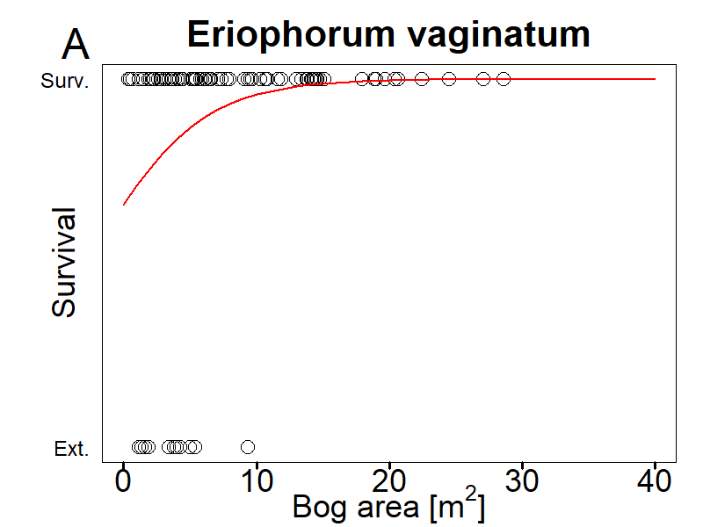

**Figure S1:** Survival probability of populations as function of site area. There was only one species (*Eriophorum vaginatum* )that showed a significant slope in a generalized linear model (at p < 0.05). For all other species see Appendix Table S4.

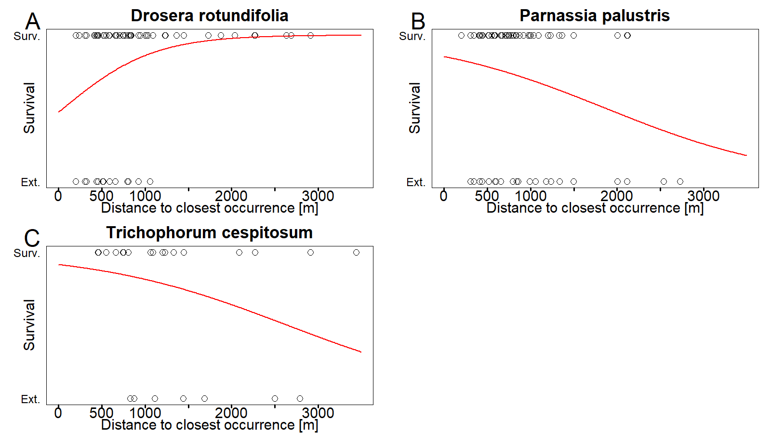

**Figure S2:** Survival probability of populations as function of distance to the next adjacent bog occupied by the species. All species are shown that have with a significant slope in a generalized linear model at p < 0.05). A) *Drosera rotundifolia*, B) *Parnassia palustris*, C) *Trichophorum cespitosum*. For all other species see Appendix Table S4.

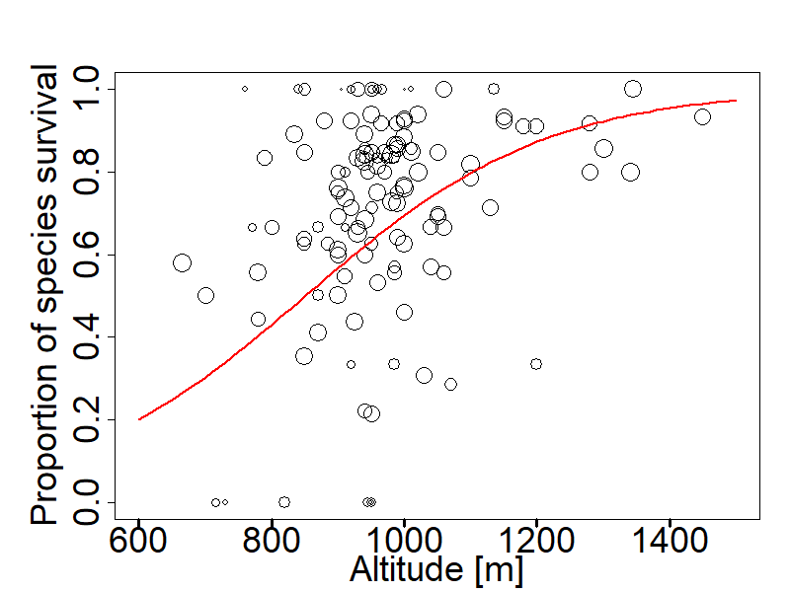

**Figure S3:** Survival rate of all populations of species that showed a decline (37 species), averaged per site (n=124) as a function of altitude. The regression line was obtained from a generalized linear model (p = 0.081). The size of symbol is proportional to the logarithm of the number of species that occurred at the site.

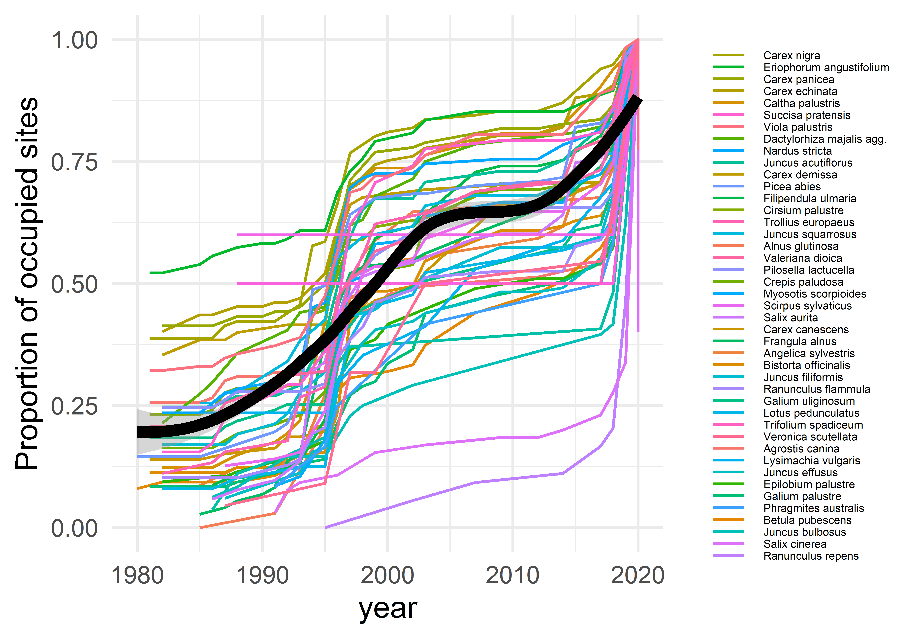

**Figure S4:** Colonization events of the 46 species with an increase in occupancy relative to the final occupancy of sites in 2020. Species are arranged according to mean occupancy. The regression line is based on a generalized additive model (gam), using local polynomial regression fitting (loess).

**Table S5:** Occupancy change observations in bog species in the Black Forest (Germany) across all sites from 1972-2019, Dryad, Dataset, <https://doi.org/10.5061/dryad.mw6m905vj>

Site_ID: number used in the map in Figure 1 and in Appendix Table S1; Species: Taxon name; Year_first_obs: Year when the species was first observed at this site; Year_last_obs: Year when the species was last observed at this site; Occ_change: indicates whether a species went extinct (-1), remained occurring (0) or newly occurred (+1) at this site; Year_subsequent_survey: Year of the subsequent survey in which the species was no longer detected at the site; Ext_event: refers to declining species and shows the extinction event (-1) that corresponds to the year of the subsequent survey.